**The Ballistic Pendulum**

[Based on PASCO lab manual 35 Ballistic Pendulum, written by Jon Hanks]

**Pre-lab questions**

1. What is the goal of this experiment? What physics and general science concepts does this activity demonstrate?
2. What is the mathematical expression for conservation of mechanical energy?
3. What is the mathematical expression for conservation of momentum?
4. When is mechanical energy conserved during this experiment? When is mechanical energy lost, and what kind of energy does it become instead?
5. When is conservation of momentum used in this experiment?

The goal of the experiment is to demonstrate the laws of conservation of momentum and conservation of mechanical energy. These laws will be used to derive the equation for the muzzle velocity of a ball shot out of a projectile launcher.

**Equipment:**

* Rotary motion sensor
* Smart gate head
* Mounting bracket
* Large table clamp
* 90-cm rod
* Mini launcher
* Ballistic Pendulum
* Meter stick
* Balance
* PASCO interface

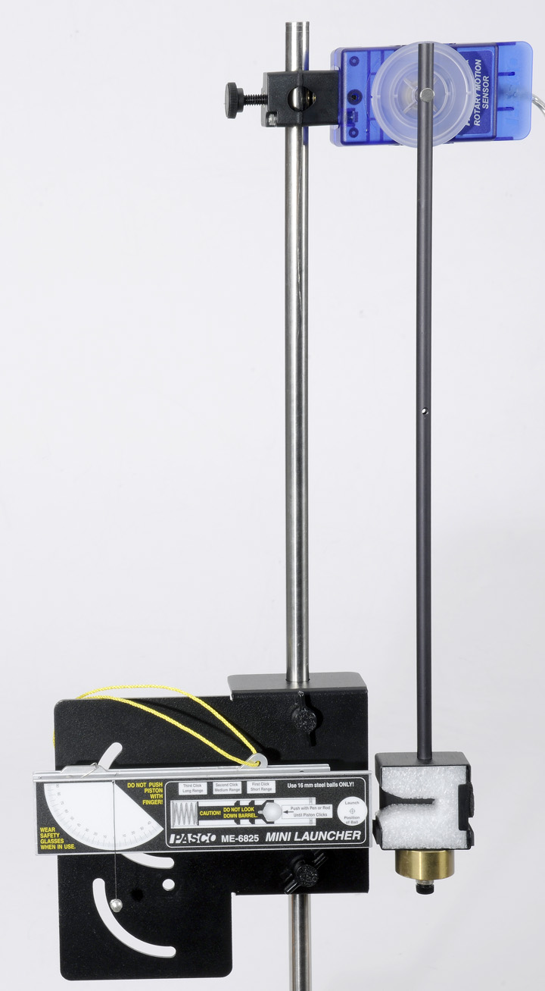

Figure 1: View of ballistic pendulum equipment setup

**Introduction:**

A ballistic pendulum is an apparatus that is used to measure the launch velocity (muzzle velocity) of a high-speed projectile. It usually consists of a pendulum arm with a basket to catch the projectile and a way to measure the final height reached by the pendulum arm after it catches the projectile.

In this experiment, a projectile launcher will fire a ball of mass, $m_{ball}$ at an initial launch velocity, $v_{0}$. The ball will be caught by a pendulum of mass, $m_{pend}$. After the momentum of the ball is transferred to the catcher-ball system, the pendulum will swing freely upwards, raising the center of mass of the system by a height, *h*. The pendulum rod is hollow to minimize its mass compared to the catcher, so that we can approximate the system as a simple pendulum.

From the description above, we can divide the experiment into three distinct time instances:

1. The moment the ball is launched with velocity, $v_{0}$. The pendulum has velocity equal to zero and is at its lowest height.
2. The moment the ball impacts the pendulum-catcher and the catcher-ball system begins to move together with a velocity, $v_{p}$, from the lowest height.
3. The moment the catcher-ball system reaches the highest height of the pendulum swing and the pendulum has an instantaneous velocity of zero.

During the inelastic collision of the ball with the catcher, the total momentum of the system is conserved. When momentum is conserved, we can say that the momentum during time instant 1 is equal to the momentum during time instant 2. Remember that momentum a vector quantity that is simply mass times velocity ($\vec{p}=m\vec{v}$); accounting for all masses in the system we have:

$$\begin{aligned}m_{ball}v_{0}+m_{pend}*0=\left(m_{ball}+m_{pend}\right)v_{p}\#\left(1\right)\end{aligned}$$

Notice that the pendulum has zero momentum before the collision because it has zero velocity before the collision. Just after the collision both masses are moving off with the same instantaneous velocity, which we have called $v_{p}$.

During the collision, some of the ball’s initial kinetic energy is converted into thermal energy. We cannot assume that mechanic energy is conserved between time instance 1 and time instance 2. However, we *can* assume that mechanical energy is conserved between time instance 2 and time instance 3 – as the pendulum swings from its lowest height to a maximum height, *h*. When mechanical energy is conserved, we say that that total mechanical energy at one instant in time is equal to total mechanical energy at a later instant in time:

$$\begin{aligned}{KE}_{2}+{PE}_{2}={KE}_{3}+{PE}_{3}\#\left(2\right)\end{aligned}$$

Filling in what we know about time instants 2 and 3:

$$\begin{aligned}\frac{1}{2}\left(m_{ball}+m_{pend}\right){v_{p}}^{2}=\left(m_{ball}+m_{pend}\right)gh\#\left(3\right)\end{aligned}$$

At instant 2, we call the pendulum height zero, so that there is zero gravitational potential energy. All mechanical energy in instant 2 is kinetic energy. At instant 3, the pendulum has come to a momentary stop at the maximum height of its swing, so all energy is gravitational potential energy.

The mass of the ball and pendulum will be found using a balance. The height reached by the pendulum will be found with a rotary motion sensor and a bit of trigonometry. The rotary motion sensor will tell us that the pendulum has moved through an angle θ. If we know the length of the pendulum (*L*), height (*h*) is given by:

$$\begin{aligned}h=L\left(1-\cos{θ}\right)\#\left(4\right)\end{aligned}$$

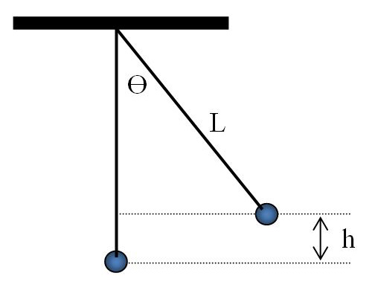

Figure 2: Diagram for finding the height reached by the pendulum

Now we can find the initial velocity of the projectile, $v_{0}$, using conservation of energy (equation (3) for this specific case) and conservation of momentum (equation (1) for this specific case). We have values for *h*, $m_{ball}$, and $m_{pend}$, so equation (3) can be rearranged:

$$\begin{aligned}v_{p}=\sqrt{2gh}\#\left(5\right)\end{aligned}$$

This can be substituted into equation (1) to give the launch velocity of the projectile:

$$\begin{aligned}v_{0}=\frac{\left(m_{ball}+m_{pend}\right)}{m_{ball}}\sqrt{2gh}\#\left(6\right)\end{aligned}$$

**Experiment 1**

***Equipment setup:***

* 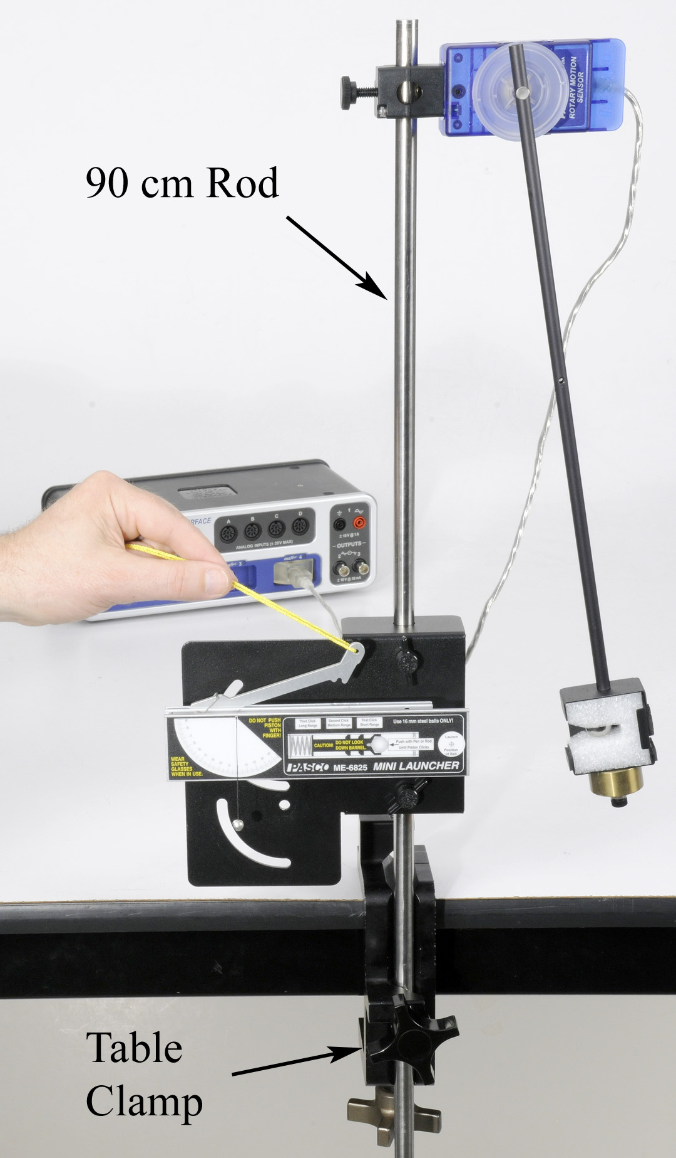Attach the table clamp with the 90-cm rod to the table as shown in figure 3.

Figure 3: Launching the ball

* Figure 4 shows the back side of the launcher bracket. Fasten the projectile launcher to the bracket using the tow thumbscrews through the two holes. Do not use the curved slots for this experiment.

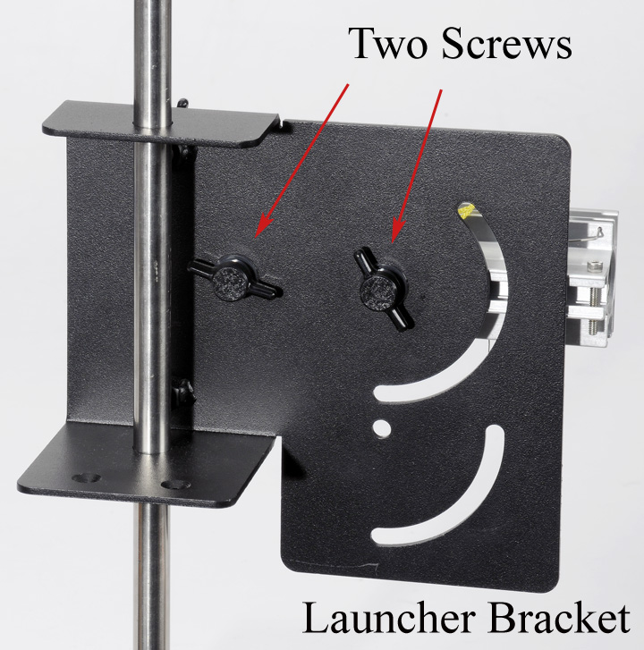

Figure 4: Launcher bracket

* Slide the launcher bracket over the rod, and secure it with the two thumbscrews on the front.
* Attach the 100-g ballast mass to the bottom of the pendulum catcher as shown in figure 5.

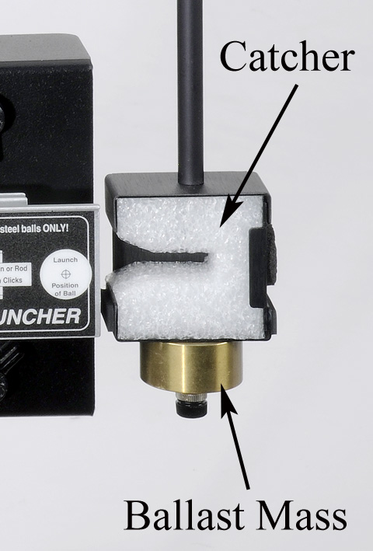

Figure 5: Ballast mass and pendulum alignment.

* Slide the rotary motion sensor onto the 90-cm rod, and attach the pendulum to the pulley.
* Connect the sensor to the interface.
* Open PASCO capstone software; begin hardware setup. Set the sample rate for the rotary motion sensor to default 20 Hz.
* Create a graph of angle (y-axis) vs. time (x-axis) in PASCO capstone.
* Click on record, then rotate the pendulum away from the launcher by hand. Check that the angle is positive. If not, you can either change the sign of the angle by using the rotary motion sensor from the other side, or you can change the sign in the properties for the sensor.
* Adjust the position of the rotary motion sensor along the 90-cm rod so that the square catcher at the bottom of the pendulum aligns with the launcher as shown in figure 5.
* Loosen the two thumb screws on the back of the launcher. Slide the launcher horizontally so that it almost (but not quite) touches the pendulum catcher. Check that the launcher is set for a launch angle of zero degrees, and then re-tighten the thumb screws.

***Procedure – measuring the angle:***

* Open the recording properties and add start and stop conditions.
  + Start recording if angle (rad) is above 0.001.
  + Stop recording if angle (rad) falls below 0.001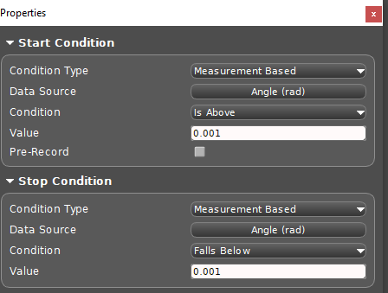
* Load the launcher by moving the pendulum out of the way and placing the ball in the end of the barrel. Use the pushrod to push the ball down the barrel until the trigger catches in the third (maximum compression) position.
* Return the pendulum to its vertical hanging position and wait until it stops moving.
* Click on record and immediately launch the ball so that it is caught in the pendulum. Stop recording after the pendulum reaches its maximum height.

*If the ball is not caught, check the alignment.*

* Record the maximum angle in data table 1.
* Repeat several times. Calculate an average value.

***Procedure – measuring length of the pendulum:***

* Remove the pendulum from the rotary motion sensor, and balance it on a meterstick as shown in figure 6. *Note that the ball is still in the catcher.*

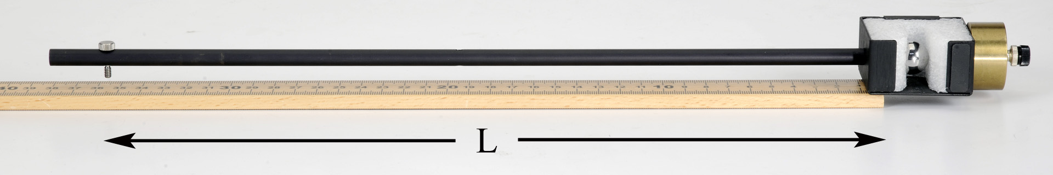

Figure 6: Finding the center of mass to find the length of the pendulum.

* Find the point at which the catcher is extended as far a possible out over the edge of the meterstick. When balanced like this, the center of mass is directly over the end of the stick.
* Record *L*, the distance from the center of mass to the pivot point (screw), in data table 1.
* Measure this several times and estimate your uncertainty. Calculate an average value.

**Data:**

[include proper units]

Table 1: Experiment 1 data.

|  |  |
| --- | --- |
| **Angle θ** | **Length *L*** |
|  |  |
|  |  |
|  |  |
|  |  |
|  |  |
|  |  |
|  |  |
|  |  |
|  |  |
|  |  |
| **Average:** | **Average:** |
| **Uncertainty:** | **Uncertainty:** |

* Mass of pendulum: $m_{pend}=$

______________________________
* Mass of ball: $m_{ball}=$

_______________________________________

**Computations and Analysis:**

* Using your average value for *L* and equation 4, calculate the height *h*.

Height = _________________________________________________

* Use equation 6 to calculate the launch speed.

$v_{0}=$

_________________________________________________

Estimated uncertainty: ____________________________

**Experiment 2**

***Equipment setup:***

* Attach the smart gate to the launcher using the photogate bracket.
* Slide the bracket so the Smart Gate is as close to the end of the launcher as possible.

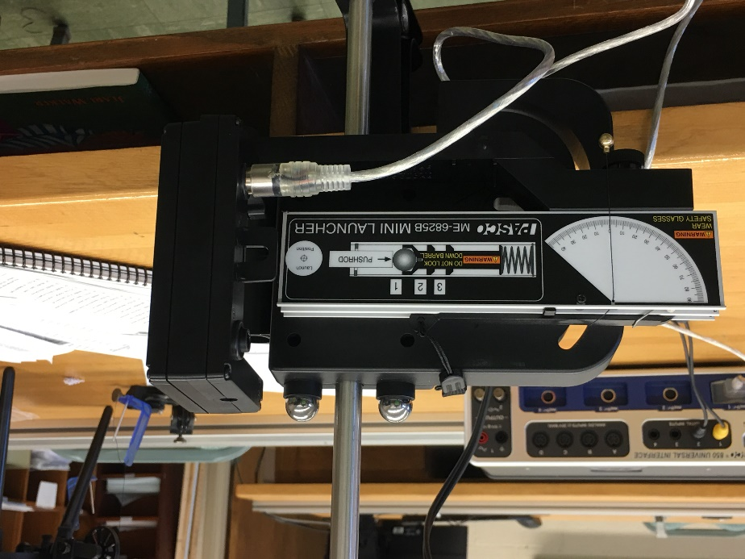

Figure 7: Launcher with Smart Gate attached to bracket.

* Connect the smart gate to the PASCO interface.
* The smart gate will automatically appear in the hardware setup.  Click on the yellow square with the 2-1 and select double flag.
* Create a digits display and change “select measurement” to “speed between the gates”.

***Procedure – measure launch speed directly:***

* Make sure that no one is down range of the ball and that it is not pointed at anything breakable.
* Click on record then launch the ball. Recording will not stop automatically, but the digits display should hold the value until the next recordable event.
* The measured speed is recorded in the digits display. Record this value in data table 2.
* Repeat several times, and calculate an average.

**Data:**

[include proper units]

Table 2: Experiment 2 data.

|  |
| --- |
| **Launch Speed $v_{0}$** |
|  |
|  |
|  |
|  |
|  |
|  |
|  |
|  |
|  |
|  |
| **Average:** |
| **Uncertainty:** |

**Conclusions:**

Compare the launch velocity found using the ballistic pendulum to the launch velocity found using the photogates. Are they equal? Why or why not?

Where in the experiment was momentum conserved?

Where in the experiment was energy conserved?

What percentage of the initially kinetic energy of the launched ball was transferred to the ball-pendulum system?

**Sources of errors:**

What assumptions were made that caused error? What is the uncertainty in your final calculation due to measurement limitations?